 | 00 (2026) 000–000  International Journal of Computing and  Business (IJCB)  Available online at https://ijcb.journals.ekb.eg/ | 

Smart Insole for Foot Ulcer Prediction

Heba Muhamed, Hassan Sherif  Ahmed Farag, Ahmed Samy  Heba Ehab  Computer Science Department  Modern Academy for Computer Science and Management Technology  In Maadi  Cairo, Egypt  hebaaly254@gmail.com hassanshiref7@gmail.com  afarag293@gmail.com  hebaehabmohamed055@gmail.com  Ahmeddsamy293@gmail.com | Dr. Lamiaa Hassaan  Assistant Professor of Computer Science Department  Modern Academy for Computer Science and Management Technology  In Maadi  Cairo, Egypt  Lamia_work@yahoo.com | Eng. Tarek EL Gamal  Teaching Assistant at Computer Science Department  Modern Academy for Computer Science and Management Technology  In Maadi  Cairo, Egypt  tarek.elgamal@outlook.com

Modern Academy for Computer Science and Management and Technology Cairo, Egypt

Abstract
Diabetic Foot Ulcer (DFU) is one of the most serious complications of diabetes mellitus, often leading to infection, hospitalization, and lower-limb amputation if not detected at an early stage. This paper presents an intelligent healthcare platform that integrates Internet of Things (IoT) technologies, embedded systems, mobile healthcare applications, and Artificial Intelligence (AI) techniques to support early diabetic foot ulcer prediction and general health monitoring. The proposed system incorporates a smart insole equipped with Force Sensitive Resistor (FSR) sensors and SHT31 temperature sensors to continuously monitor plantar pressure distribution and foot temperature variations. Sensor data are transmitted through an ESP32 microcontroller and analyzed using a Random Forest model for ulcer risk prediction. In addition, a MobileNetV2-based deep learning model is employed to classify diabetic foot ulcer images into four severity grades. The platform also includes stroke risk prediction, general disease prediction, nutrition planning, and an AI-powered healthcare assistant within a Flutter-based mobile application. Experimental results demonstrate the effectiveness of the proposed system in providing real-time monitoring, automated risk assessment, and AI-assisted healthcare recommendations. The integration of IoT and AI technologies enables proactive healthcare management, early intervention, and remote patient monitoring, contributing to improved healthcare outcomes and quality of life for diabetic patients.
Keywords: Diabetic Foot Ulcer; Internet of Things; Smart Insole; MobileNetV2; Random Forest; Healthcare Monitoring; Artificial Intelligence.

Introduction
Diabetic Foot Ulcer (DFU) is one of the most serious complications of diabetes mellitus and can lead to severe infections and lower-limb amputation if not detected early. Continuous monitoring of foot pressure and temperature has become an effective approach for identifying ulcer risk factors before serious complications occur.
Recent advancements in Artificial Intelligence (AI), Internet of Things (IoT), and wearable healthcare technologies have enabled the development of intelligent systems capable of real-time patient monitoring and early disease prediction. These technologies provide opportunities for improving healthcare accessibility and supporting preventive medical interventions.
In this paper, an intelligent healthcare platform is proposed that integrates a smart insole equipped with pressure and temperature sensors, machine learning models for ulcer prediction, and a mobile healthcare application for monitoring and visualization. The system also incorporates diabetic foot ulcer image classification, stroke risk prediction, and general health assessment modules to provide a comprehensive healthcare solution.
The proposed platform aims to support early diagnosis, continuous monitoring, and AI-assisted healthcare recommendations, thereby improving patient outcomes and quality of life.

2. Related Work
Diabetic Foot Ulcer (DFU) is one of the most serious complications associated with diabetes mellitus and is considered a major cause of lower-limb amputation worldwide. Early detection and continuous monitoring of foot conditions are essential for preventing severe complications and improving patient outcomes. Recent healthcare research has focused on the development of intelligent monitoring systems capable of identifying ulcer risk factors before clinical symptoms become critical.
The emergence of Internet of Things (IoT) technologies has enabled the development of wearable healthcare devices for continuous physiological monitoring. Smart insoles equipped with pressure and temperature sensors have been widely investigated as effective tools for monitoring plantar pressure distribution and detecting abnormal foot conditions associated with diabetic foot complications. Pressure concentration and localized temperature variations are considered important indicators of ulcer formation and tissue damage.
Artificial Intelligence (AI) techniques have also demonstrated significant potential in healthcare monitoring and disease prediction. Machine learning algorithms have been utilized to analyze sensor measurements and identify patterns associated with diabetic foot ulcer development. These approaches support early risk assessment and enable preventive healthcare interventions.
In addition, deep learning models have achieved remarkable performance in medical image analysis. MobileNet and MobileNetV2 architectures have been successfully applied in healthcare image classification tasks because of their lightweight design, computational efficiency, and suitability for mobile and edge-based applications. These characteristics make them appropriate for diabetic foot ulcer severity classification within real-time healthcare systems.
Although previous studies have investigated either sensor-based monitoring or image-based diabetic foot ulcer analysis, most existing approaches focus on a single prediction technique. The proposed system combines smart insole sensing, embedded IoT communication, machine learning-based ulcer risk prediction, and MobileNetV2-based diabetic foot ulcer image classification within a unified healthcare platform. This integrated approach provides continuous monitoring, early ulcer detection, and AI-assisted healthcare support through a mobile healthcare application.

3. Proposed Work
The proposed system presents an intelligent healthcare platform designed for early diabetic foot ulcer prediction and continuous health monitoring. The system integrates embedded hardware, IoT communication, machine learning, deep learning, and mobile healthcare technologies into a unified solution.

3.1 System Architecture
The proposed architecture consists of four main layers:
- Data Acquisition Layer
- Communication Layer
- Artificial Intelligence Layer
- Mobile Application Layer
The data acquisition layer is responsible for collecting foot pressure and temperature measurements using sensors embedded within a smart insole. The communication layer transmits sensor readings from the ESP32 microcontroller to the mobile application using Bluetooth Low Energy (BLE). The application displays real-time monitoring data and synchronizes the collected measurements with the backend server. The AI layer then processes the sensor data to generate ulcer risk predictions and healthcare recommendations, which are presented to the user through the mobile application.
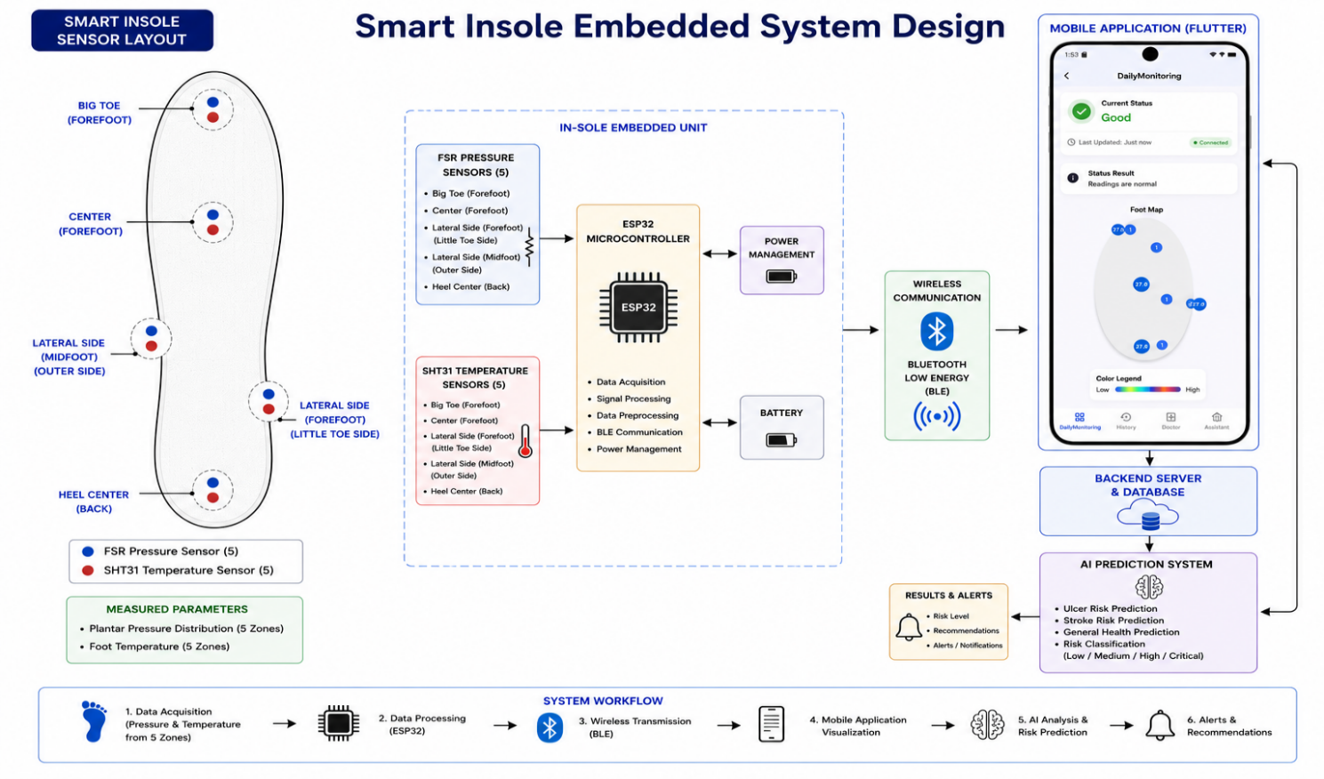
Figure 1. Proposed smart insole embedded system architecture for diabetic foot ulcer monitoring and prediction.

3.2 Smart Insole Design
A smart insole was developed to continuously monitor foot conditions during daily activities. The insole incorporates multiple Force Sensitive Resistor (FSR) sensors positioned at critical pressure points of the foot to measure plantar pressure distribution.
In addition, SHT31 temperature sensors are used to monitor foot temperature variations. The combination of pressure and temperature measurements provides important indicators for identifying potential ulcer development.

3.3 Embedded System and IoT Communication
The sensing system is controlled by an ESP32 microcontroller due to its low power consumption, processing capabilities, and built-in Bluetooth connectivity.
The ESP32 continuously reads sensor values from the smart insole and transmits the collected data to the mobile application. This enables real-time monitoring and remote healthcare support.

3.4 Diabetic Foot Ulcer Prediction
Pressure and temperature data collected from the smart insole are processed and analyzed using a Random Forest machine learning model.
The model is trained to identify patterns associated with diabetic foot ulcer risk and classify patients according to their risk level. By analyzing sensor measurements continuously, the system can provide early warnings before severe complications occur.

3.5 Diabetic Foot Ulcer Image Classification
The proposed platform also includes an image-based diabetic foot ulcer assessment module.
A MobileNetV2 deep learning model is utilized to classify diabetic foot ulcer images into four severity grades. The lightweight architecture of MobileNetV2 enables efficient deployment within mobile healthcare applications while maintaining high classification performance.

3.6 Mobile Healthcare Application
A mobile application was developed using Flutter to provide a user-friendly interface for patients and healthcare providers.
The application allows users to:
- View real-time pressure and temperature readings.
- Monitor ulcer risk predictions.
- Upload foot images for ulcer classification.
- Access healthcare recommendations and notifications.
- Track personal health information.
The integration of embedded systems, IoT technologies, machine learning, and deep learning enables the development of a comprehensive healthcare platform for diabetic foot ulcer prevention and monitoring.

4. Results and Discussion
The proposed smart healthcare system was evaluated with primary focus on the smart insole subsystem and diabetic foot ulcer prediction functionality. Experimental testing was conducted to assess sensor performance, data transmission reliability, image classification accuracy, and overall system integration.
The smart insole successfully acquired plantar pressure and foot temperature measurements using FSR pressure sensors and SHT31 temperature sensors connected to the ESP32 microcontroller. The collected sensor readings were transmitted to the backend infrastructure and mobile application in real time, enabling continuous monitoring of foot health conditions. Testing results demonstrated stable sensor operation and reliable wireless communication with minimal data transmission delays.
The diabetic foot ulcer prediction module was evaluated using a medical image dataset and the MobileNetV2 deep learning architecture. The trained model achieved an overall classification accuracy of approximately 94%, with high precision, recall, and F1-score values across all ulcer severity grades. The confusion matrix indicates that the model effectively differentiates between healthy feet and multiple ulcer severity levels, demonstrating strong classification capability for diabetic foot assessment.
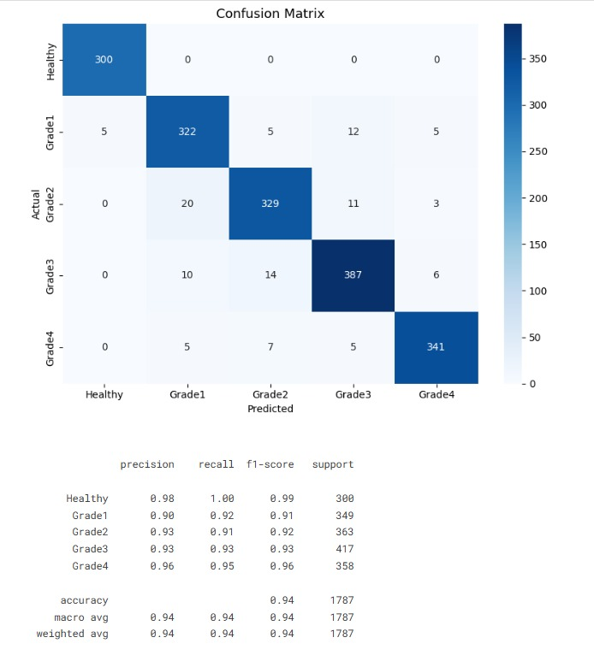
Figure 2. MobileNetV2 Confusion Matrix and Classification Report
In addition to image-based analysis, the integration of pressure and temperature measurements from the smart insole provided complementary healthcare information that can support early identification of abnormal foot conditions associated with diabetic complications. The combination of embedded sensing technology and artificial intelligence improves the effectiveness of preventive healthcare monitoring.
The complete system integration was successfully validated through the interaction between the smart insole device, ESP32 microcontroller, backend services, cloud database, and Flutter mobile application. Real-time visualization of sensor readings and prediction results was achieved within the mobile application interface.
Several additional healthcare modules were also implemented, including stroke risk prediction, general disease prediction, medical report analysis, and AI-assisted healthcare support. These modules demonstrated satisfactory performance and enhanced the overall functionality of the healthcare platform; however, they were considered supplementary features compared to the primary objective of diabetic foot ulcer prediction and smart foot monitoring.
Overall, the experimental results demonstrate that the proposed smart insole system provides an effective framework for continuous diabetic foot monitoring and AI-assisted ulcer risk assessment, supporting early detection and preventive healthcare interventions.

5. Conclusion
This paper presented an intelligent healthcare system for diabetic foot monitoring and diabetic foot ulcer prediction based on the integration of embedded sensing technology, artificial intelligence, and mobile healthcare applications.
The proposed smart insole was designed using FSR pressure sensors, SHT31 temperature sensors, and an ESP32 microcontroller to continuously monitor plantar pressure distribution and foot temperature variations. Real-time sensor readings were transmitted to the healthcare platform, enabling continuous foot health assessment and monitoring.
In addition, a MobileNetV2-based deep learning model was implemented for diabetic foot ulcer image classification. Experimental results demonstrated strong classification performance, achieving high accuracy across multiple ulcer severity grades. The integration of sensor-based monitoring and AI-driven image analysis provided a comprehensive approach for diabetic foot assessment and early risk identification.
The developed mobile application successfully visualized sensor measurements, prediction results, and healthcare recommendations, providing an accessible interface for continuous patient monitoring.
Overall, the obtained results demonstrate the feasibility of combining embedded systems, Internet of Things (IoT) technologies, and artificial intelligence to support preventive healthcare monitoring and early diabetic foot ulcer detection. The proposed system represents a promising solution for improving diabetic foot care and reducing the risk of severe ulcer-related complications through continuous monitoring and intelligent healthcare analysis.

6. References

[1] A. Howard, M. Zhu, B. Chen, D. Kalenichenko, W. Wang, T. Weyand, M. Andreetto, and H. Adam, “MobileNets: Efficient Convolutional Neural Networks for Mobile Vision Applications,” arXiv preprint arXiv:1704.04861, 2017.

[2] M. Sandler, A. Howard, M. Zhu, A. Zhmoginov, and L. Chen, “MobileNetV2: Inverted Residuals and Linear Bottlenecks,” in Proc. IEEE Conf. Computer Vision and Pattern Recognition (CVPR), 2018, pp. 4510–4520.

[3] TensorFlow, “TensorFlow Documentation.” [Online]. Available: https://www.tensorflow.org/

[4] Kaggle, “Diabetic Foot Ulcer (DFU) Dataset.” [Online]. Available: https://www.kaggle.com/datasets/laithjj/diabetic-foot-ulcer-dfu

[5] World Health Organization (WHO), “Diabetes.” [Online]. Available: https://www.who.int/health-topics/diabetes

[6] American Diabetes Association, “Standards of Medical Care in Diabetes.” [Online]. Available: https://diabetesjournals.org/

[7] Espressif Systems, “ESP32 Technical Documentation.” [Online]. Available: https://www.espressif.com/

[8] Sensirion, “SHT31 Temperature and Humidity Sensor Datasheet.” [Online]. Available: https://sensirion.com/

[9] Bluetooth SIG, “Bluetooth Low Energy Technology Overview.” [Online]. Available: https://www.bluetooth.com/

[10] Flutter, “Flutter Documentation.” [Online]. Available: https://docs.flutter.dev/

[11] FastAPI, “FastAPI Documentation.” [Online]. Available: https://fastapi.tiangolo.com/

[12] Supabase, “Supabase Documentation.” [Online]. Available: https://supabase.com/docs

[13] L. Aversano et al., “A Systematic Review on Artificial Intelligence Approaches for Smart Healthcare Systems,” 2024. [Online]. Available: https://pmc.ncbi.nlm.nih.gov/articles/PMC11623213/

